
Annual Tech Fest 2025
Why Participate
- To know about the real world problem
- For building Network
- Interaction with varity of people
- To know about the updated world technology
Rules
- Every participants is strictly provided to use any kind of help form other participants
- None is allowed to use any kind of online AI sites.
- Any violation of rules will get a penalty

EVENTS
- Beinner Programming Contest
- AI Fest
- TAKE-OFF
- Cyber Flag
- Promt Battle
CONTACT
Email – daffodil2002@gmail.com
Phone Number : 01864103655
Birulia , Savar ,Dhaka , Bangladesh

Events | Start Time | End Time
Contest | 9.00 A.M. | 11.00 A.M.
AI Fest | 9.30 A.M | 12.00 P.M
TAKE-OFF | 12.00 P.M. | 2.00 P.M
Cyber Flag | 9.30 A.M | 2.30 P.M.
Promt Battle | 1.30 P.M | 5.30 P.M
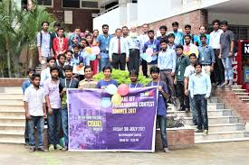
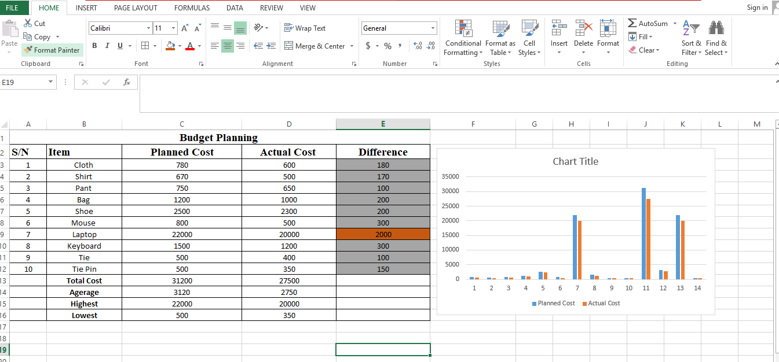

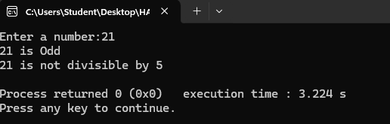

else
{
printf("%d is Odd\n",N);
if(N%5==0)
{
printf("%d is divisible by 5\n",N);
}
else
{
printf("%d is not divisible by 5\n",N);
}
}
return 0;
}
#include<stdio.h>

int main()
{
int N;

printf("Enter a number:");
scanf("%d", &N);

if(N%2==0)
{
printf("%d is Even\n",N);
if(N%5==0)
{
printf("%d is divisible by 5\n",N);
}
else
{
printf("%d is not divisible by 5\n",N);
}
}

